Analyzer Board Manual

Horatio He, July, 2013

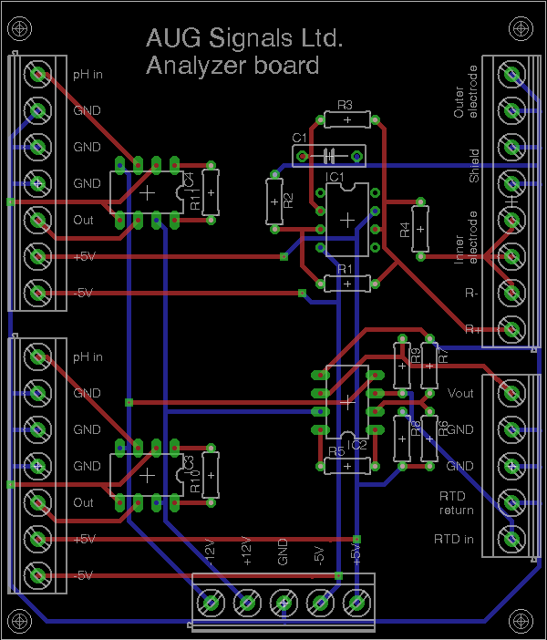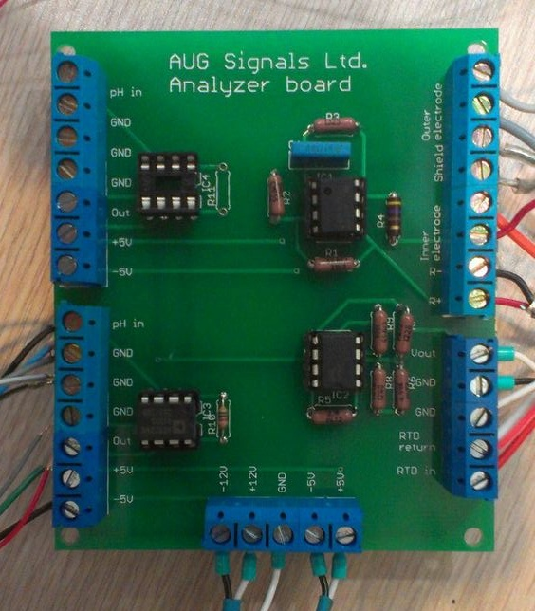

The analyzer board is divided into four circuits, each having a separate set of terminal blocks. The board requires a DC power supply which provides ±12V and ±5V to operate all circuits. We currently use the Power-One MAP500-4000.

**Top left and bottom left:**

Instrumentation amplifier circuits used for pH and ORP probes. Instrumentation amplifier is an AD622AN. Uses a 5.6k resistor for a gain of 10. Requires ±12V.

**Top right:**

Conductivity measurement circuit for the Rosemount 400-12 conductivity probe, to be used with the GUI shown below. See “Rosemount Analyzer Replacement - Conductivity.docx” for the theory behind operation. Requires ±12V and ±5V.

**Bottom right:**

RTD linearization circuit. Intended for use with the Pt1000 RTD found on the conductivity probe. See “RTD testing.docx” for theory behind operation. Requires ±12V and ±5V. Note the RTDs found on the pH and ORP probes are Pt100, and cannot be used without changing the resistors. The document describes how to select new resistor values.

# Wiring

## Conductivity

|  |  |
| --- | --- |
| **Terminal** | **Connect to…** |
| Outer electrode | DAQ AI probe channel - |
| Outer electrode | Conductivity probe gray |
| Shield | Conductivity probe clear |
| Shield | Conductivity probe clear |
| Inner electrode | DAQ AI probe channel + |
| Inner electrode | Conductivity probe orange |
| R- | DAQ AI shunt resistor channel - |
| R+ | DAQ AI shunt resistor channel + |

*The GUI allows you to specify which ai channels were selected for the DAQ connections.

## RTD

|  |  |
| --- | --- |
| **Terminal** | **Connect to…** |
| Vout | DAQ AI RTD channel + |
| GND | DAQ AI RTD channel - |
| GND | Probe clear |
| RTD return | Probe white and red/white |
| RTD in | Probe red |

*The conductivity, pH, and ORP probes all have the same wire colouring for the RTD leads. As mentioned above, this manual will describe everything for the Pt1000 RTD on the conductivity probe.

# Conductivity and Temperature Measurement

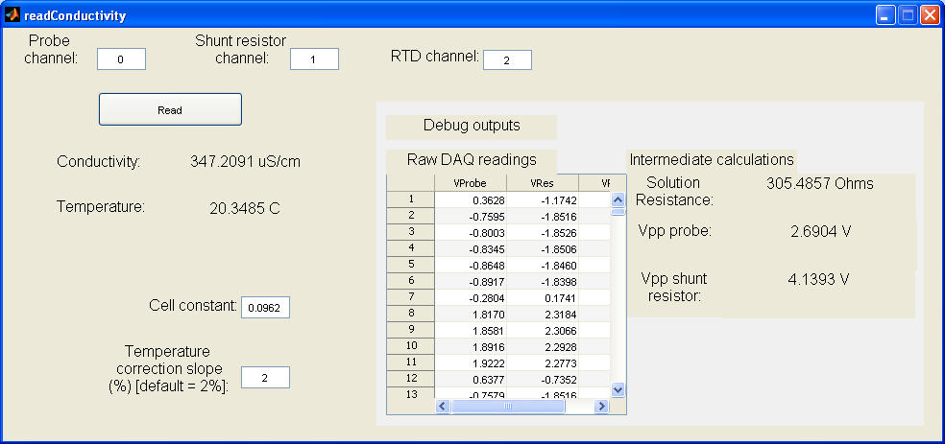

The development GUI for the conductivity reading is written in MATLAB. To run it, open readConductivity.m in MATLAB and hit F5. The program is hardcoded for a NI USB-6210 addressed at Dev4, with a shunt resistor of 470 Ohms. The DAQ channels that were connected for the probe, shunt resistor, and RTD are specified at the top.

The conductivity measurement circuit consists of a square wave generator, the output of which is sent across a shunt resistor and the probe electrodes. The resultant voltages across the probe electrodes and the shunt resistor are measured and shown in the Raw DAQ readings table. As these are both square waves, we calculate the average peak-to-peak voltages, and the resultant conductivity.

The RTD linearization circuit takes the RTDs resistance and converts it to a voltage. The components are selected such that the output produces 0V at -5°C to 5V at 55°C for a Pt1000.

## Calibrating conductivity

The conductivity probe takes a 1 point calibration. Using a conductivity standard (recommended 500uS/cm) , enter a new cell constant using:

New cell constant = Old cell constant * (expected conductivity/current reading)

$$New cell constant=Old cell constant×\frac{Expected conductivity}{Measured conductivity}$$

# Circuit assembly

|  |  |
| --- | --- |
| **Location** | **Component** |
| R1 | 4.99k |
| R2 | 4.99k |
| R3 | 2.2k |
| R4 | 470 |
| R5 | 2.1k |
| R6 | 4.99k |
| R7 | 970 |
| R8 | 4.99k |
| R9 | 100k |
| R10 | 5.6k **gain resistor, gives gain of 10 |
| R11 | 5.6k ** |
| C1 | 0.1u |
| IC1 | Op amp, UA741CP |
| IC2 | Instrumentation amp, AD622AN |
| IC3 | AD622AN |
| IC4 | AD622AN |